**DSPLAB Assignment – 3**

1. Write a source code how to implement efficiently multiple queues in a single array

Source Code:

#include <stdio.h>

#define MAX 40

void insert_que1(int *,int *,int *,int);

void insert_que2(int *,int *,int *,int);

void insert_que3(int *,int *,int *,int);

void insert_que4(int *,int *,int *,int);

void delete_que1(int *,int *,int *,int *);

void delete_que2(int *,int *,int *,int *);

void delete_que3(int *,int *,int *,int *);

void delete_que4(int *,int *,int *,int *);

void display_que1(int *,int *,int *);

void display_que2(int *,int *,int *);

void display_que3(int *,int *,int *);

void display_que4(int *,int *,int *);

int c1=0;

int c2=0;

int c3=0;

int c4=0;

void main()

{

int que[MAX];

int front1,rear1,front2,rear2,front3,rear3,front4,rear4;

int value,choice,i;

front1 = rear1 = -1;

front2 = rear2 = 20;

front3 = rear3 = 20;

front4 = rear4 = 40;

for(i=0;i<MAX;i++)

que[i]=-1;

START:

do

{

printf("\n______________________________________");

printf("\n 1. insert to queue1\n");

printf("\n 2. insert to queue2\n");

printf("\n 3. insert to queue3\n");

printf("\n 4. insert to queue4\n");

printf("\n 5. delete to queue1\n");

printf("\n 6. delete to queue2\n");

printf("\n 7. delete to queue3\n");

printf("\n 8. delete to queue4\n");

printf("\n 9. Display elements in Queue1\n");

printf("\n 10. Display elements in Queue2\n");

printf("\n 11. Display elements in Queue3\n");

printf("\n 12. Display elements in Queue4\n");

printf("\n 13. Display elements in ALLQueues\n");

printf("\n 14. Quit\n");

printf("\n______________________________________");

printf("\n\tENTER CHOICE HERE :");

scanf("%d",&choice);

switch(choice)

{

case 1 : printf("Enter the element to be inserted:\n");

scanf("%d",&value);

insert_que1(que,&front1,&rear1,value);

break;

case 2 : printf("Enter the element to be inserted:\n");

scanf("%d",&value);

insert_que2(que,&front2,&rear2,value);

break;

case 3 : printf("Enter the element to be inserted:\n");

scanf("%d",&value);

insert_que3(que,&front3,&rear3,value);

break;

case 4 : printf("Enter the element to be inserted:\n");

scanf("%d",&value);

insert_que4(que,&front4,&rear4,value);

break;

case 5 : delete_que1(que,&front1,&rear1,&value);

if(value == -1)

printf("Deque_1 is empty\n");

else

printf("The value deleted from front is %d\n",value);

break;

case 6 : delete_que2(que,&front2,&rear2,&value);

if(value == -1)

printf("Deque_2 is empty\n");

else

printf("The value deleted from front is %d\n",value);

break;

case 7 : delete_que3(que,&front3,&rear3,&value);

if(value == -1)

printf("Deque_3 is empty\n");

else

printf("The value deleted from front is %d\n",value);

break;

case 8 : delete_que4(que,&front4,&rear4,&value);

if(value == -1)

printf("Deque_4 is empty\n");

else

printf("The value deleted from front is %d\n",value);

break;

case 9 : display_que1(que,&front1,&rear1);

break;

case 10 : display_que2(que,&front2,&rear2);

break;

case 11 : display_que3(que,&front3,&rear3);

break;

case 12 : display_que4(que,&front4,&rear4);

break;

case 13 : printf("\n\tMULTIPLE QUEUES:\n");

display_que1(que,&front1,&rear1);

display_que2(que,&front2,&rear2);

display_que3(que,&front3,&rear3);

display_que4(que,&front4,&rear4);

break;

case 14 : printf("\npress any key to QUIT !!!\n");

goto EXIT;

default: goto START;

}

}while(1);

EXIT:

getch();

}

void insert_que1(int que[],int *front1,int *rear1,int value)

{

int i,k;

if(*front1 == 0 && *rear1 == MAX-11)

{

printf("Deque_1 is full.\n");

return;

}

if(*rear1 == -1)

{

*rear1=*front1=0;

que[*rear1]=value;

c1++;

return;

}

if(*rear1 == MAX-11)

{

printf("shifting");

k=*front1-1;

for(i=1;i<=c1;i++)

{

que[k]=que[k+1];

k++;

}

que[k]=value;

*rear1=k;

(*front1)++;

c1++;

}

else

{

(*rear1)++;

que[*rear1]=value;

c1++;

}

}

void insert_que2(int que[],int *front2,int *rear2,int value)

{

int i,k;

if(*front2 == MAX-1 && *rear2 == MAX-10)

{

printf("Deque_2 is full.\n");

return;

}

if(*rear2 == 20)

{

*rear2=*front2=19;

que[*rear2]=value;

c2++;

return;

}

if(*rear2 == MAX-10)

{

printf("shifting");

k=*front2-1;

for(i=1;i<=c2;i++)

{

que[k]=que[k-1];

k--;

}

que[k]=value;

*rear2=k;

(*front2)--;

c2++;

}

else

{

(*rear2)--;

que[*rear2]=value;

c2++;

}

}

void insert_que3(int que[],int *front3,int *rear3,int value)

{

int i,k;

if(*front3 == 20 && *rear3 == MAX-31)

{

printf("Deque_3 is full.\n");

return;

}

if(*rear3 == 20)

{

*rear3=*front3=21;

que[*rear3]=value;

c3++;

return;

}

if(*rear3 == MAX-31)

{

printf("shifting");

k=*front3-21;

for(i=1;i<=c1;i++)

{

que[k]=que[k+1];

k++;

}

que[k]=value;

*rear3=k;

(*front3)++;

c3++;

}

else

{

(*rear3)++;

que[*rear3]=value;

c3++;

}

}

void insert_que4(int que[],int *front4,int *rear4,int value)

{

int i,k;

if(*front4 == MAX-21 && *rear4 == MAX-30)

{

printf("Deque_4 is full.\n");

return;

}

if(*rear4 == 40)

{

*rear4=*front4=39;

que[*rear4]=value;

c4++;

return;

}

if(*rear4 == MAX-30)

{

printf("shifting");

k=*front4-1;

for(i=1;i<=c4;i++)

{

que[k]=que[k-1];

k--;

}

que[k]=value;

*rear4=k;

(*front4)--;

c4++;

}

else

{

(*rear4)--;

que[*rear4]=value;

c4++;

}

}

void delete_que1(int que[],int *front1,int *rear1,int *value)

{

if(*front1 == -1)

{

printf("Deque_1 is empty\n");

*value=-1;

return;

}

*value = que[*front1];

que[*front1]=-1;

if(*front1 == *rear1)

{

*front1=-1;

*rear1=-1;

*value=-1;

c1--;

}

else

{

(*front1)++;

c1--;

}

}

void delete_que2(int que[],int *front2,int *rear2,int *value)

{

if(*front2 == 20)

{

printf("Deque_1 is empty\n");

*value=-1;

return;

}

*value = que[*front2];

que[*front2]=-1;

if(*front2 == *rear2)

{

*front2=20;

*rear2=20;

*value=-1;

c2--;

}

else

{

(*front2)--;

c2--;

}

}

void delete_que3(int que[],int *front3,int *rear3,int *value)

{

if(*front3 == 20)

{

printf("Deque_3 is empty\n");

*value=20;

return;

}

*value = que[*front3];

que[*front3]=-1;

if(*front3 == *rear3)

{

*front3=20;

*rear3=20;

*value=20;

c3--;

}

else

{

(*front3)++;

c3--;

}

}

void delete_que4(int que[],int *front4,int *rear4,int *value)

{

if(*front4 == 40)

{

printf("Deque_4 is empty\n");

*value=20;

return;

}

*value = que[*front4];

que[*front4]=20;

if(*front4 == *rear4)

{

*front4=40;

*rear4=40;

*value=20;

c4--;

}

else

{

(*front4)--;

c4--;

}

}

void display_que1(int *que,int *front1,int*rear1)

{

int i;

printf("\n QUEUE NO 1 :\t");

if(*front1 == -1 || *rear1 == -1)

printf("Deque_1 is empty\n");

else

{ printf("front->");

for(i=*front1;i<=*rear1;i++)

printf(" %d",que[i]);

printf(" <-rear");

}

}

void display_que2(int *que,int *front2,int*rear2)

{

int i;

printf("\n QUEUE NO 2 :\t");

if(*front2 == 20 || *rear2 == 20)

printf("Deque_2 is empty\n");

else

{ printf("front->");

for(i=*front2;i>=*rear2;i--)

printf(" %d",que[i]);

printf(" <-rear");

}

}

void display_que3(int *que,int *front3,int*rear3)

{

int i;

printf("\n QUEUE NO 3 :\t");

if(*front3 == 20 || *rear3 == 20)

printf("Deque_3 is empty\n");

else

{ printf("front->");

for(i=*front3;i<=*rear3;i++)

printf(" %d",que[i]);

printf(" <-rear");

}

}

void display_que4(int *que,int *front4,int*rear4)

{

int i;

printf("\n QUEUE NO 4 :\t");

if(*front4 == 40 || *rear4 == 40)

printf("Deque_4 is empty\n");

else

{ printf("front->");

for(i=*front4;i>=*rear4;i--)

printf(" %d",que[i]);

printf(" <-rear");

}

}

Output:

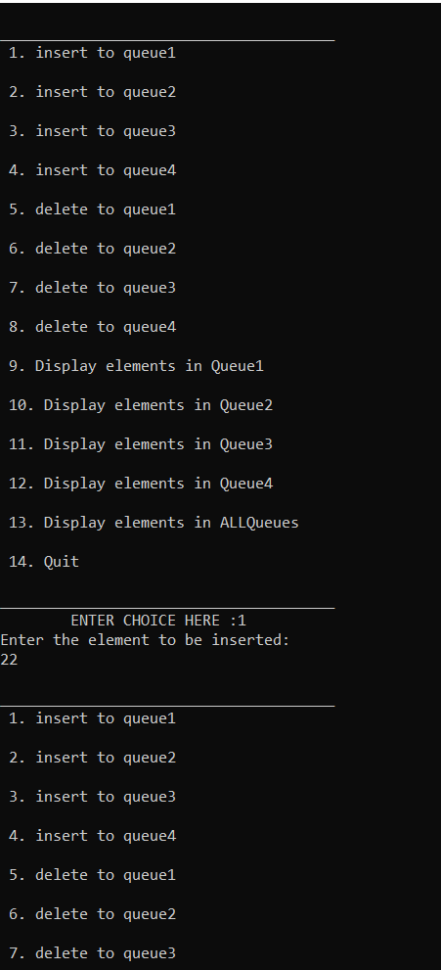 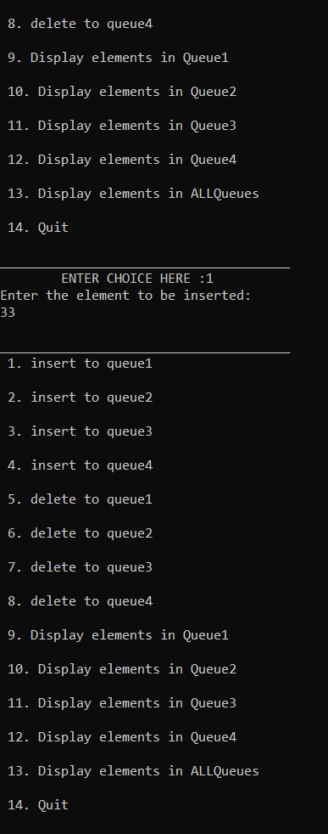 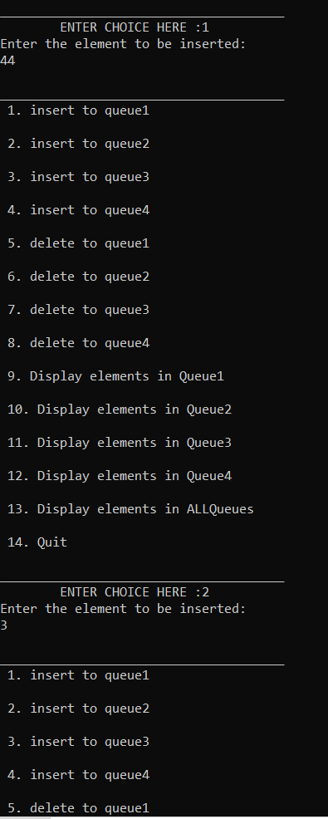 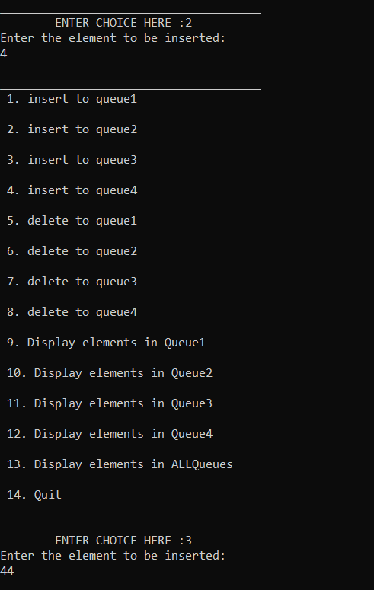

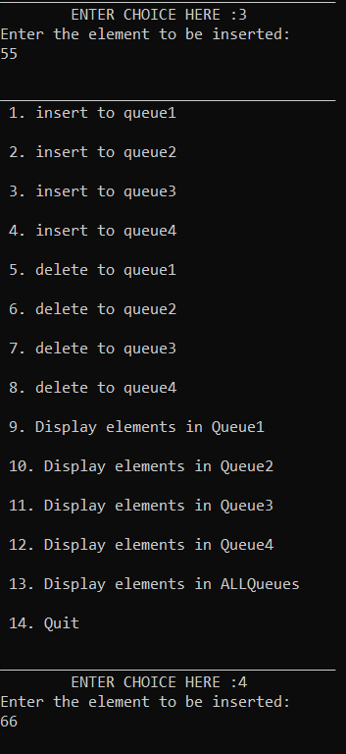

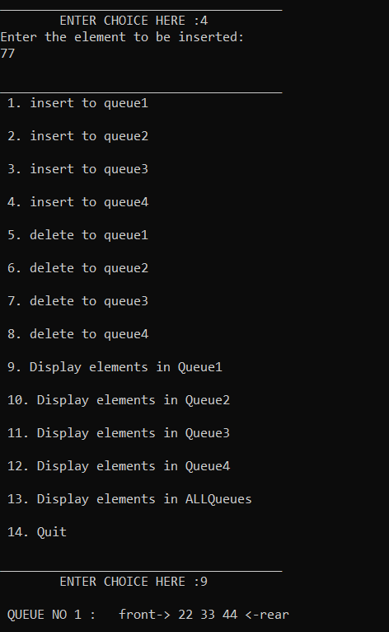

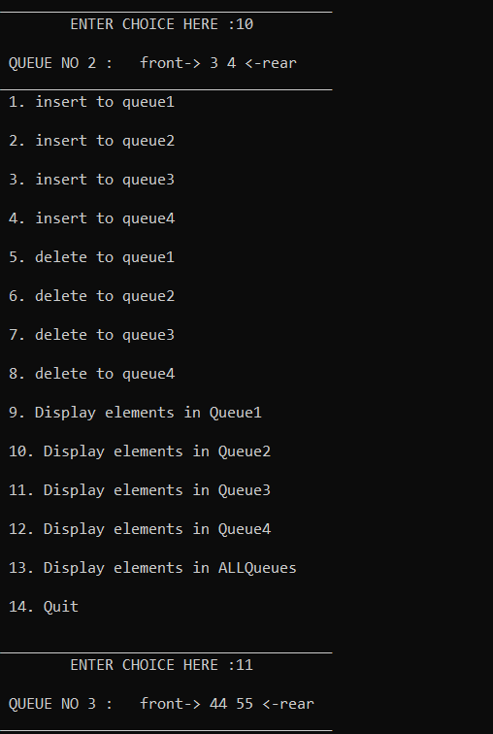

Output2:

